C:\Users\traecit2\Desktop\excelsoft_logo.png

***CREATING VM FROM IMAGE***



| Document Details | |
| --- | --- |
| Type Of Information | **Document Data** |
| Document Title |  |
| Document Reference Number |  |
| Document Owner |  |
| Security Classification |  |
| Review Frequency |  |

| Document Approval | | | |
| --- | --- | --- | --- |
| Name | **Role** | **Signature** | **Date** |
| Mahesh Jambardi | Chief Operating Officer | Mahesh Jambardi |  |
| Srinivas Chudamani | Sr. Manager IT & IS Infrastructure | Srinivas Chudamani |  |

| Version Control Details | | | |
| --- | --- | --- | --- |
| Version  Number | **Revision Date** | **Prepared by** | **Nature of Change** |
| 1.0 |  |  |  |
| 2.0 |  |  |  |
| 3.0 |  |  |  |
| 4.0 |  |  |  |
| 4.1 |  |  |  |
| 4.2 |  |  |  |
| 4.3 |  |  |  |
| 5.0 |  |  |  |

**Table of Contents**

[**1.**](#_heading=h.30j0zll)  **4**

[**2.**](#_heading=h.2et92p0)  **4**

[**2.1.**](#_heading=h.tyjcwt)

[**3.**](#_heading=h.lnxbz9)  **9**

[**3.1.** 9](#_heading=h.35nkun2)

[**4.**](#_heading=h.1y810tw) **REFERENCE 11**

**Steps:**

1. Log in to the Azure portal, find for Snapshots in the Resource group.

From the Resource group click on the snapshot that you want to use to create a

new disk.

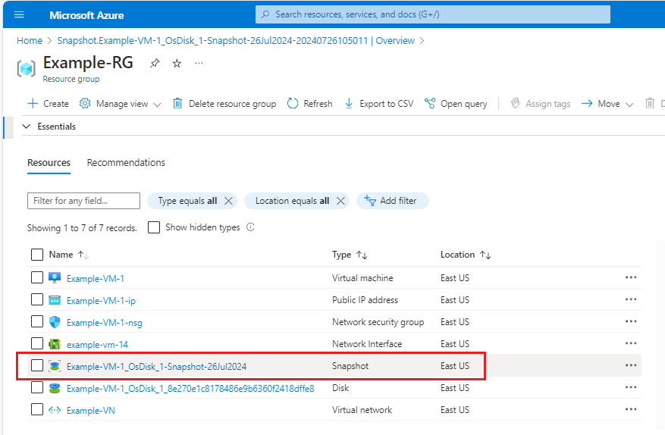

1. Click on Create disk

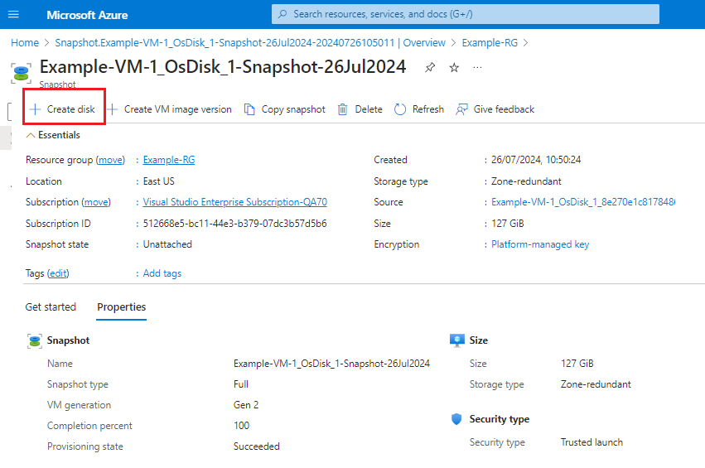

1. **Configure Disk Settings**:

* **Subscription**: Ensure the correct subscription is selected.
* **Resource group**: Choose or create a new resource group where the new disk will be placed.
* **Disk name**: Provide a name for the new disk.
* **Source snapshot**: The snapshot you selected should already be pre-populated.
* **Location**: Choose the Azure region where the disk will be stored.

1. **Configure Disk Options**:

* **Account type**: Select the desired disk type Standard HDD
* **Size (GiB)**: Specify the size of the new disk. You can choose a size equal to or larger than the original snapshot size.

1. **Review + Create**:

* **Review the settings to ensure they are correct.**
* **C**lick on **Review + create** to proceed.

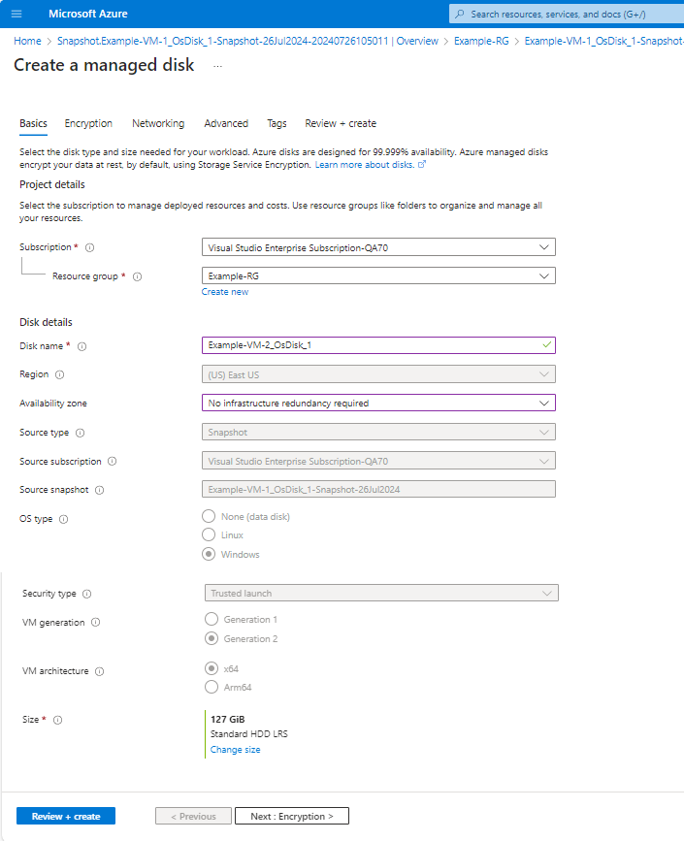

1. After the validation passes, click on **Create** to start the process of creating the new disk from the snapshot.

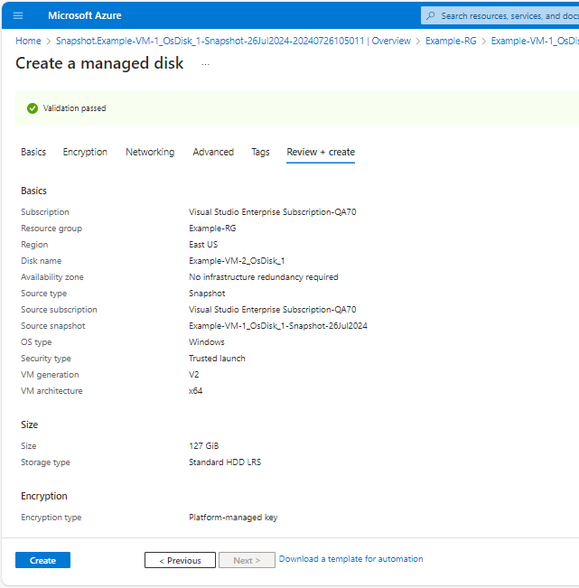

1. You can monitor the deployment progress in the notifications pane.

Once the disk creation process is complete, you will see a notification indicating success. You can also navigate to the resource group where you created the disk to verify its existence.

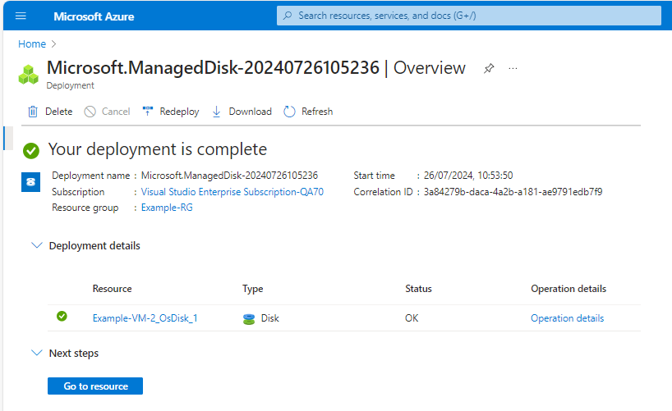

Step 8: To create VM from Disk, select disk

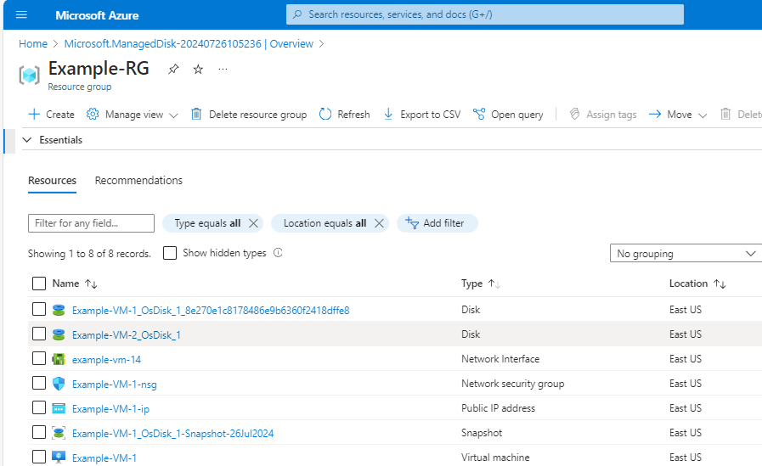

1. Click on Create VM

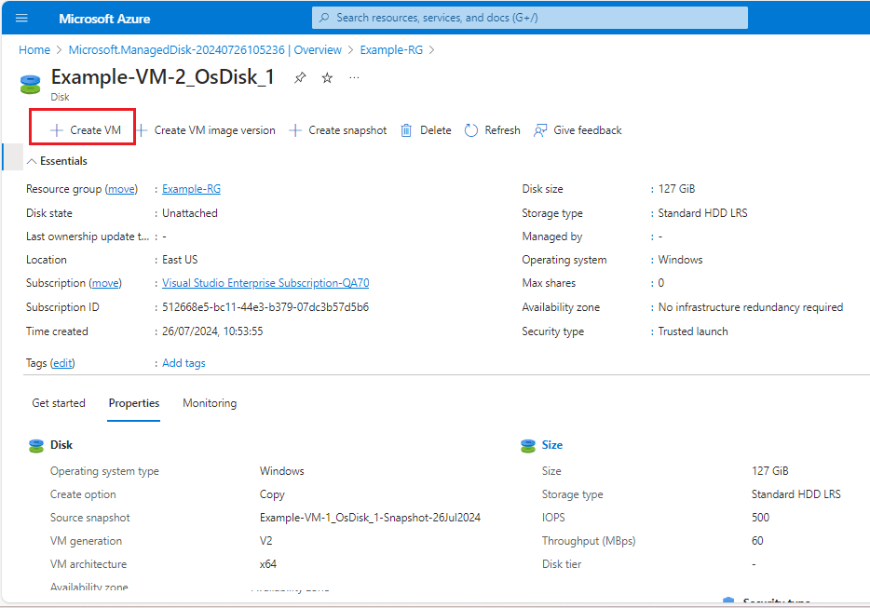

1. **Basics tab**:

* **Subscription**: Ensure the correct subscription is selected.
* **Resource group**: Choose or create a new resource group for the new VM.
* **Virtual machine name**: Provide a name for your new VM.
* **Availability options**: No infrastructure redundancy required.
* **Image**: Select **None (No image available)** because you are creating the VM from a managed disk.

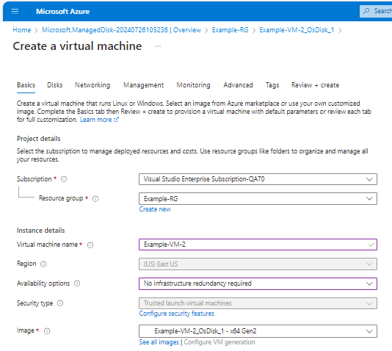

* **VM size:** As per user required
* **InBond Port** : HTTP , HTTPS & RDP.
* **License type :** Windows server
* **Click** **Next: Disks** when you're done.

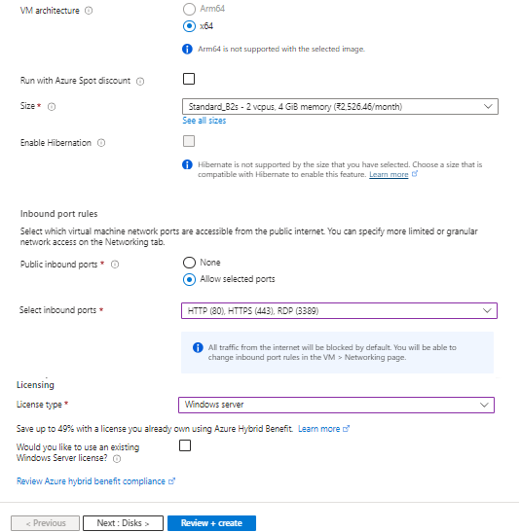

1. **In Disk**

* **OS disk type**: Choose the type of OS disk (Standard HDD or Standard SSD as per requirment)
* **OS disk name**: Provide a name for the OS disk of the new VM.
* **Source type**: Select **Attach existing disk**.
* **Source disk**: Choose the managed disk you selected earlier from the **drop**-down list.
* **Click** **Review + create** when you're done.

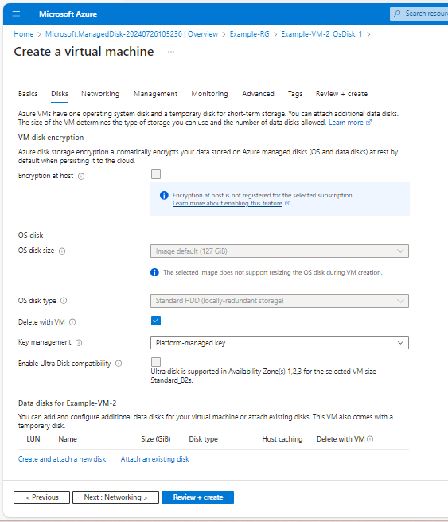

1. **In Networking**

* Select Virtual network if already created or click on Create new
* Public Network : Click on to create new
* NIC Network security group : Basic
* Public Inbound Ports : Allow selected ports and also select the HTTP, HTTPS & RDP ports.
* Click Review + Create

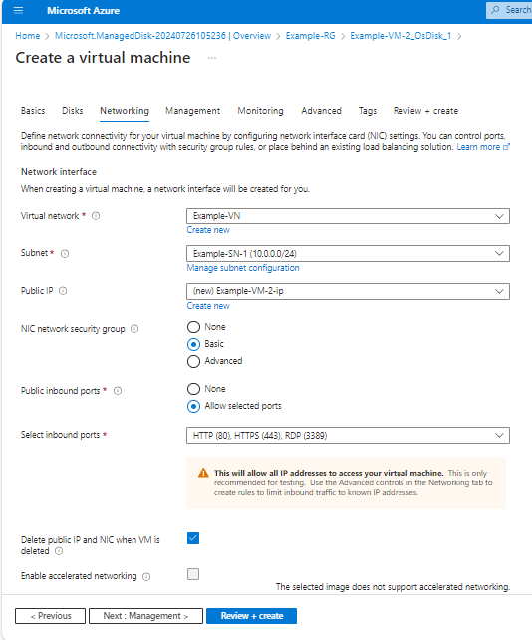

VM created

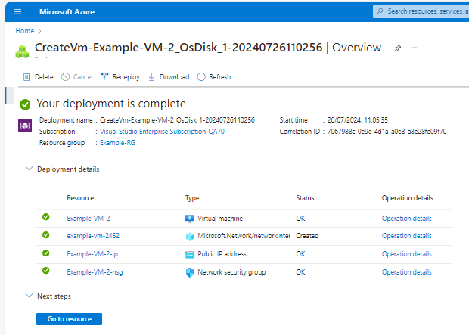

VM details

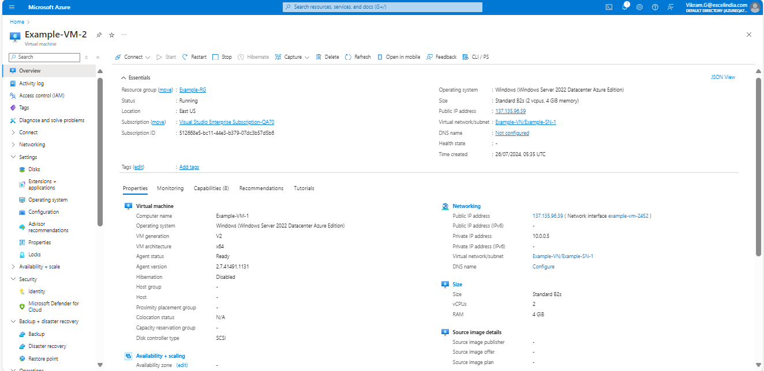

1. NSG Best Practices

* In VM Network setting
* Under Network security group
* In RDP Port enter ES IP address



 